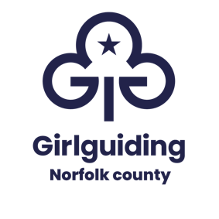

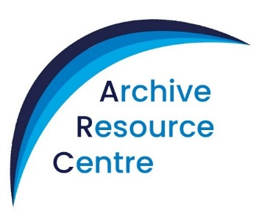
Where guiding history comes alive!

Charity number 280532

Booking the ARC Building and its Resources or a Virtual Session

Thank you for your interest in using Girlguiding Norfolk’s Archive Resource Centre.
We hope you find this checklist helpful!
- Action
- Contact the County Archivist archivist@girlguidingnofolk.org.uk to discuss a date and your requirements. The County Archivist will then arrange for the required forms to be sent to you.

- Do you want to book an ARC Package – a 2 hour session including resources, led by a member of the Archive Team? If so read the ARC Hire Charges sheet and complete the ‘ARC Resources/Speaker’ booking form

- Is your session going to be at the ARC?
Complete the ARC Building Booking Contract.

- Are you just hiring ARC resources offsite?
Complete the ‘ARC Resource Hire only’ booking form.

- Are you just hiring the building?
Complete the ARC Building Booking Contract.

- Are you arranging a virtual session?
Complete the ARC Virtual Session Booking Form.

- Want to purchase badges?
Look at the ARC website to see what is currently available.
- Return forms to archivist@girlguidingnorfolk.org.uk
You will be sent an invoice confirming the payment due. Payment may be made by cheque or BACS. On receipt of your fee, your booking is confirmed. Therefore please pay as soon as possible.
If appropriate you will be sent instructions regarding building entry, etc.

We hope you enjoy your visit and look forward to your feedback!

