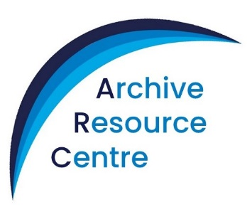
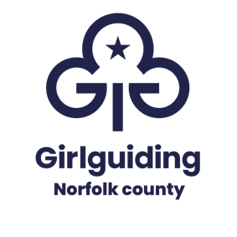
Where guiding history comes alive!

Charity No – 280532

Invoice:

ARC Resources/Speaker Booking Form
where an ARC Package is being booked

Please complete this form once you have discussed a date and your requirements with the County Archivist archivist@girlguidingnorfolk.org.uk

Print in block letters please
Name
Group
Address
Town |  | Post Code
Tel No (Home) |  | Mobile
Email

Date of Event
 | From (time) | To (time)

Estimated Number of Participants
Rainbows | Brownies | Guides | Rangers | Adults

Session agreed with County Archivist

If this is a return visit what did you do before?

Any additional sensory needs – to facilitate appropriate session planning
If not taking place at the ARC – taking place at (please tick):

My meeting place |  | Hautbois House
Patteson Lodge |  | Elsewhere

Address of venue:
Address
Town |  | Post Code
From (time) |  | To (time)

Do you want to buy badges? If so please see the ARC website for the list of badges currently available.

If the session is taking place at the ARC please also complete an ARC Building Booking Contract Form.

Payment
Please email this form to archivist@girlguidingnorfolk.org.uk

An invoice will then be sent confirming the payment due. Payment may be made by cheque or BACS. A receipt will be emailed on request.

Terms of Hire:
I agree to ensure the contents of each box are returned having been checked against the inventory, that they are undamaged, laundered (if appropriate) and returned on the agreed date and time.

I consent to Girlguiding Norfolk County collecting my details via this form. I understand that the information provided will be processed by Girlguiding Norfolk County in accordance with General Data Protection Requirements, that the data will only be used for processing my booking and that it will not be shared with other organisations or kept for longer than necessary for this purpose. Full details are included in the Girlguiding Norfolk County Privacy Notice available on request.

Signed: Date:

